**AWS ASSIGNMENT NO :- 1**

* **Create 6 IAM Users:**

1. Alice

2. Bob

3. Charles

4. David

5. Edward

6. Fred

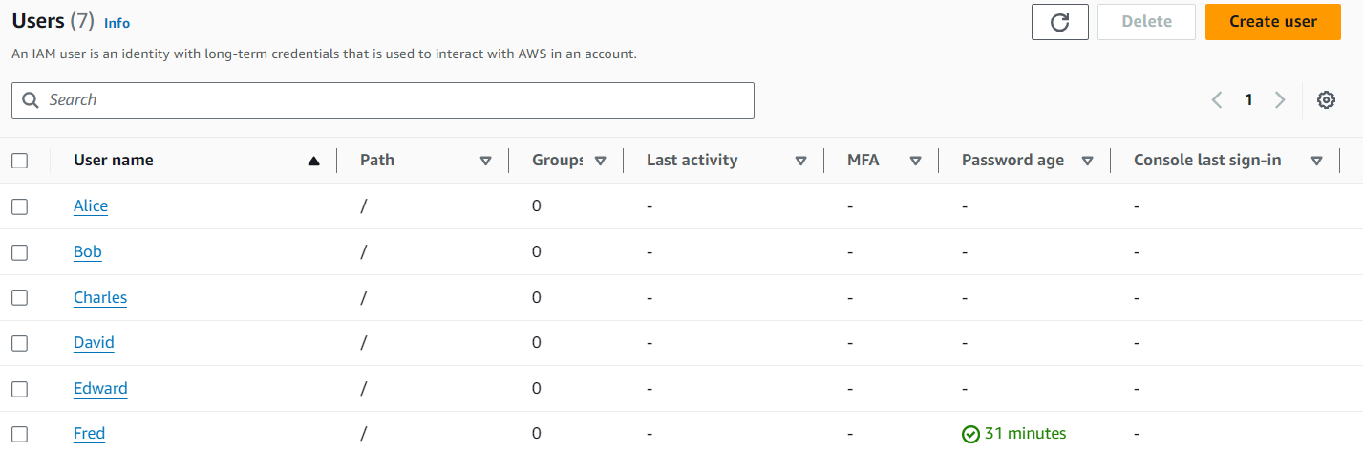

* **Create 3 groups:**

1. Developers

2. Operations

3. Audit-Team

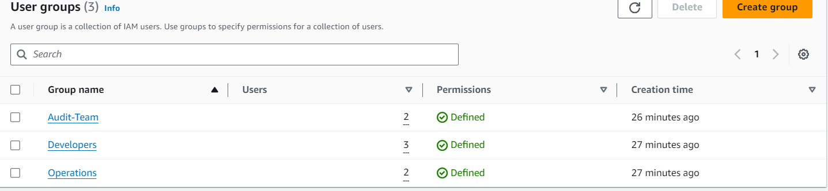

* **Assign the "IAMReadOnlyAccess" policy to the Developers group.**

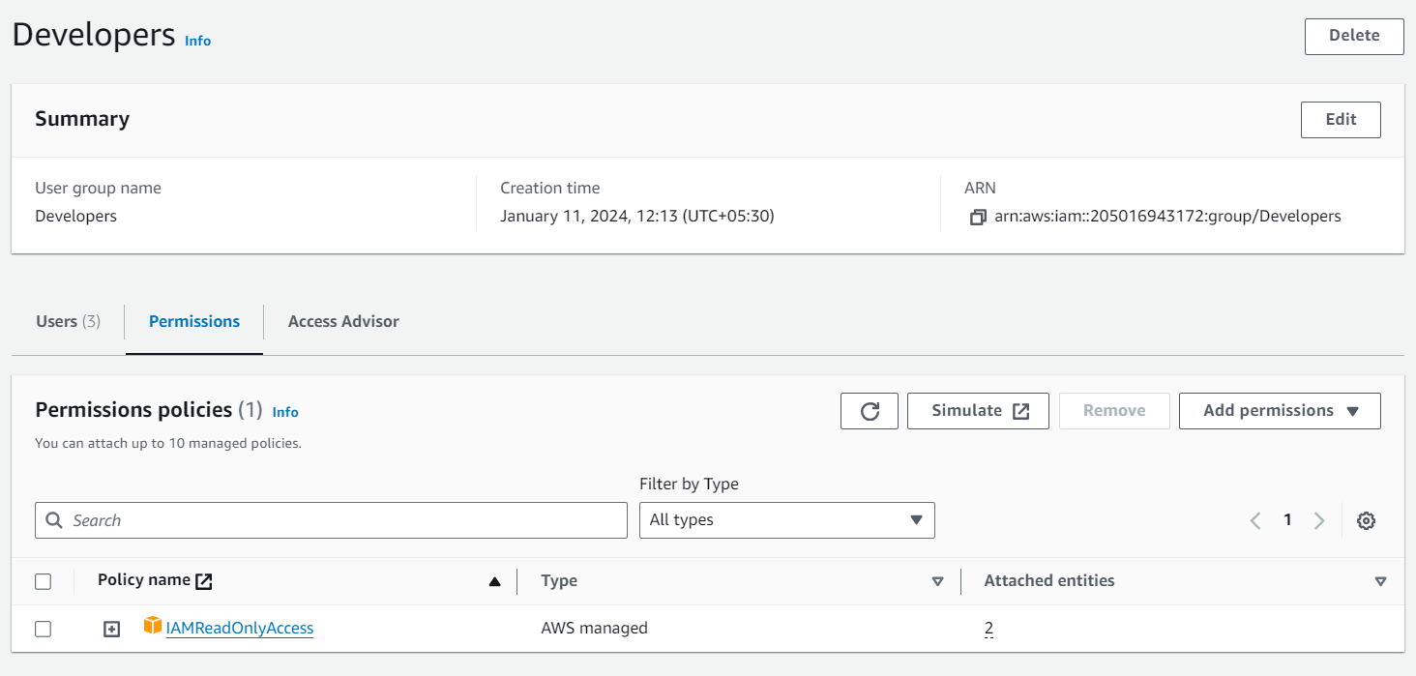

* **Assign the "IAMReadOnlyAccess" policy to the Operations group.**

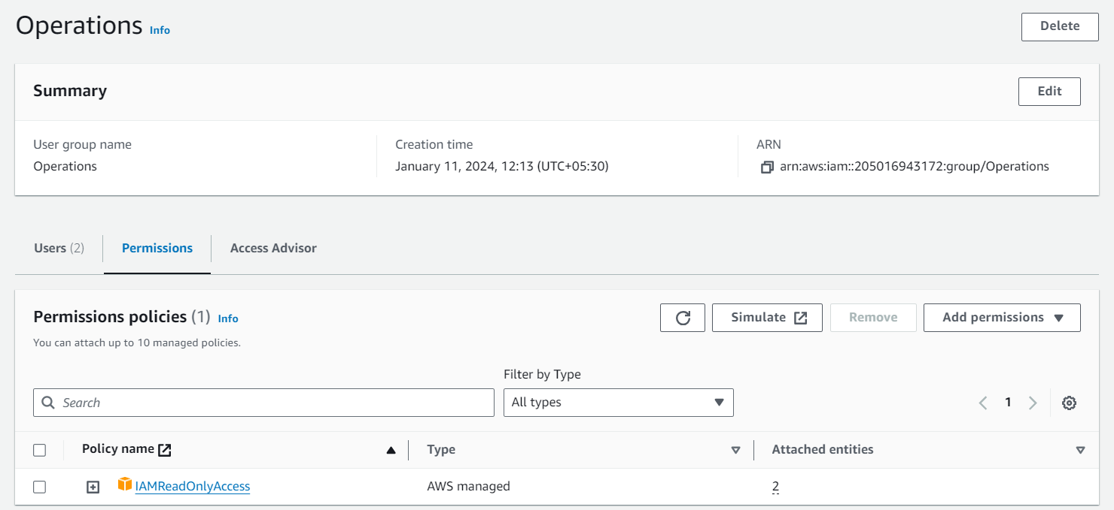

* **Assign the "IAMFullAccess" policy to the Audit-Team group.**

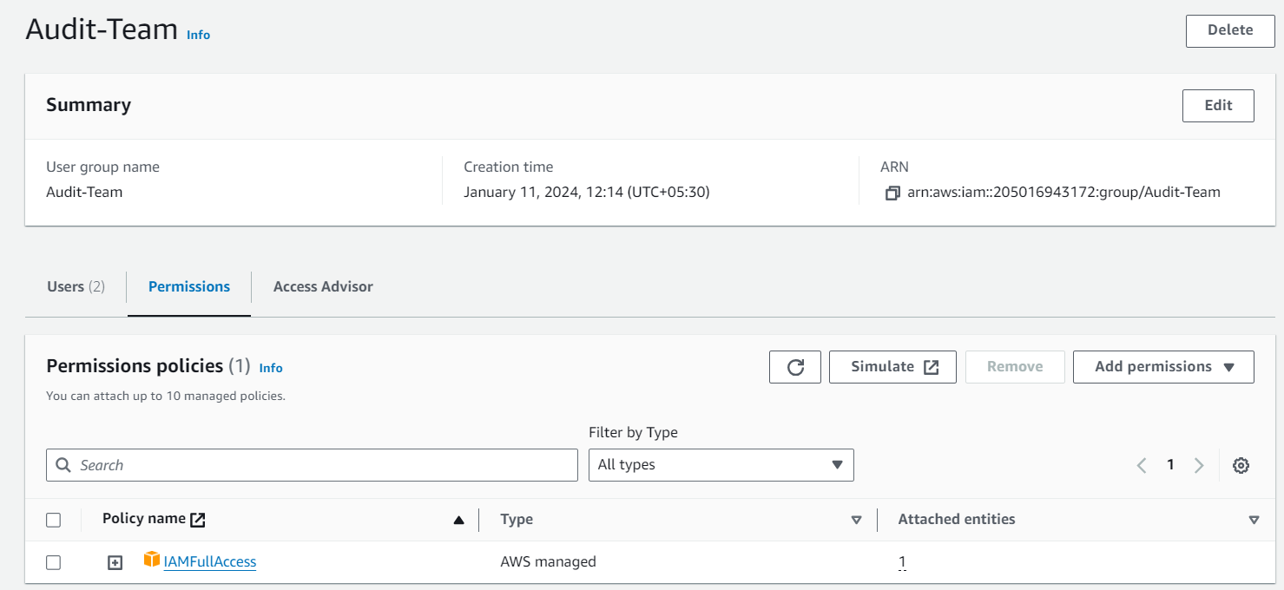

* **Add Alice, Bob, and Charles to the Developers group.**

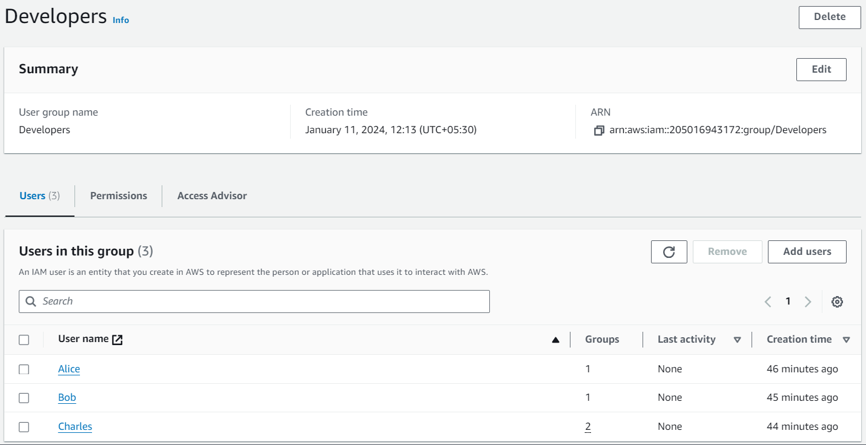

* **Add David and Edward to the Operations group.**

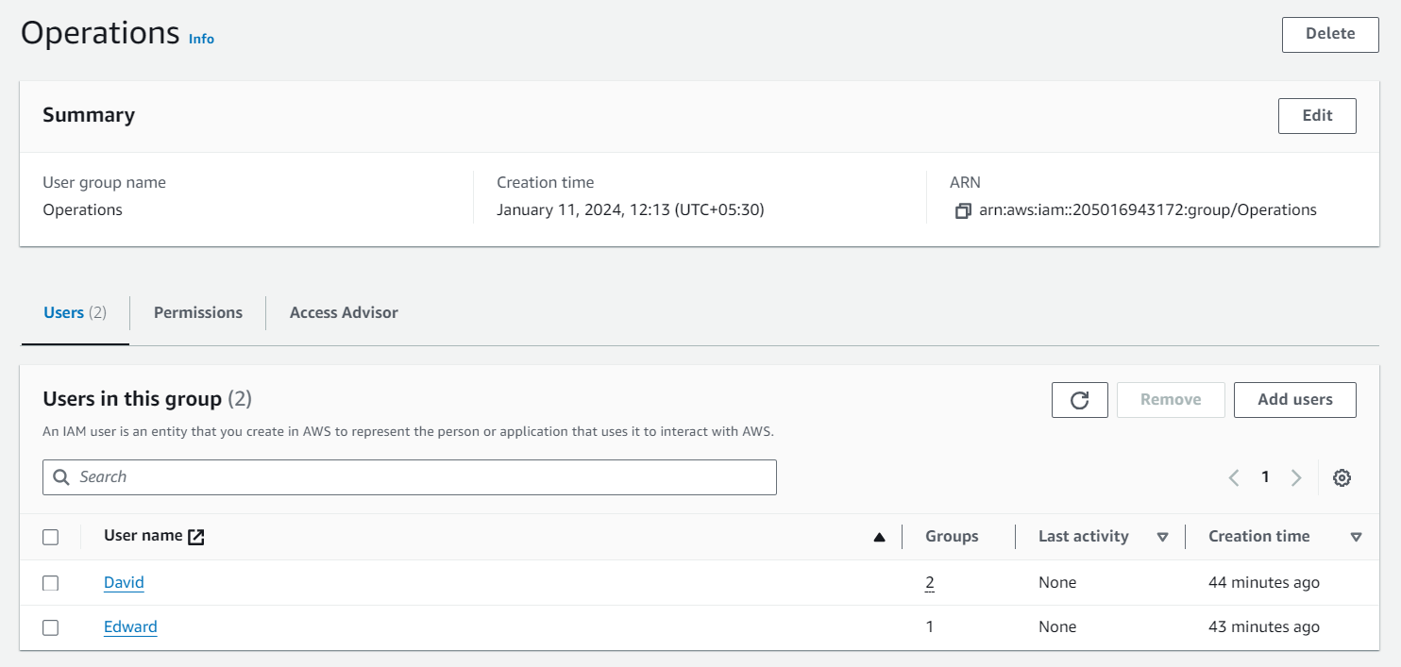

* **Add Charles and David to the Audit-Team group.**

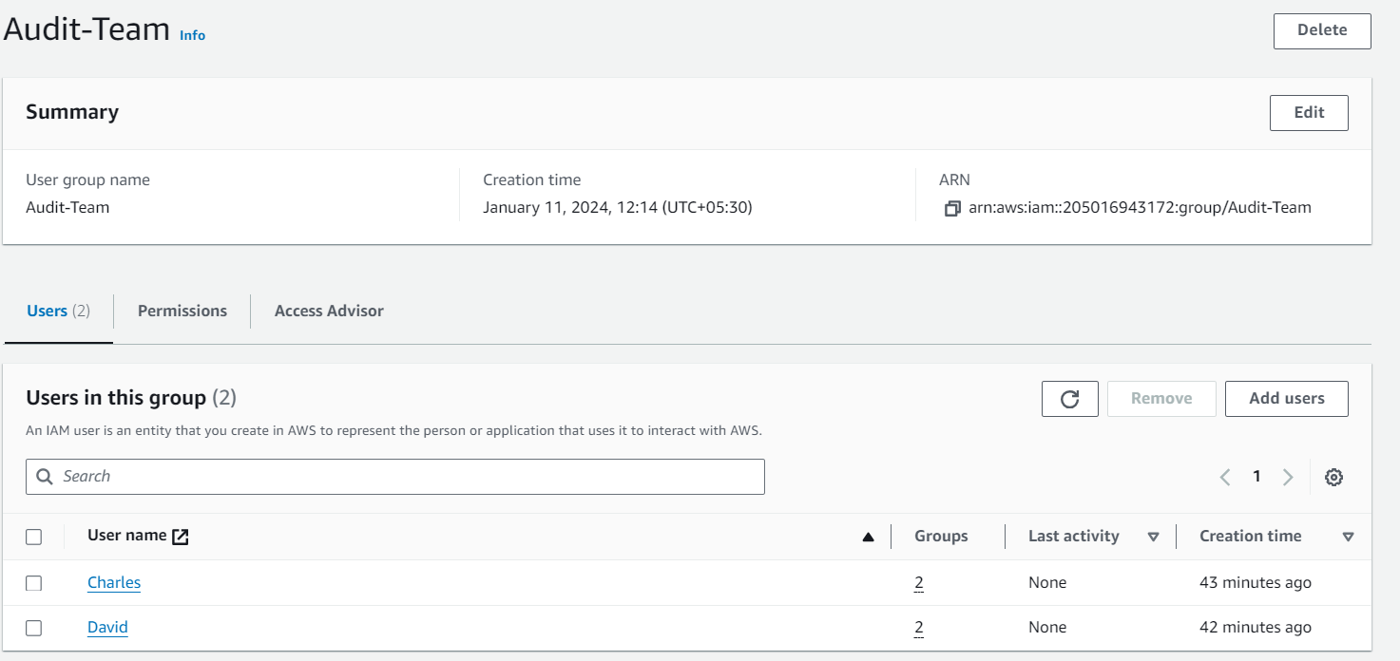

* **Assign an inline policy to Fred.**

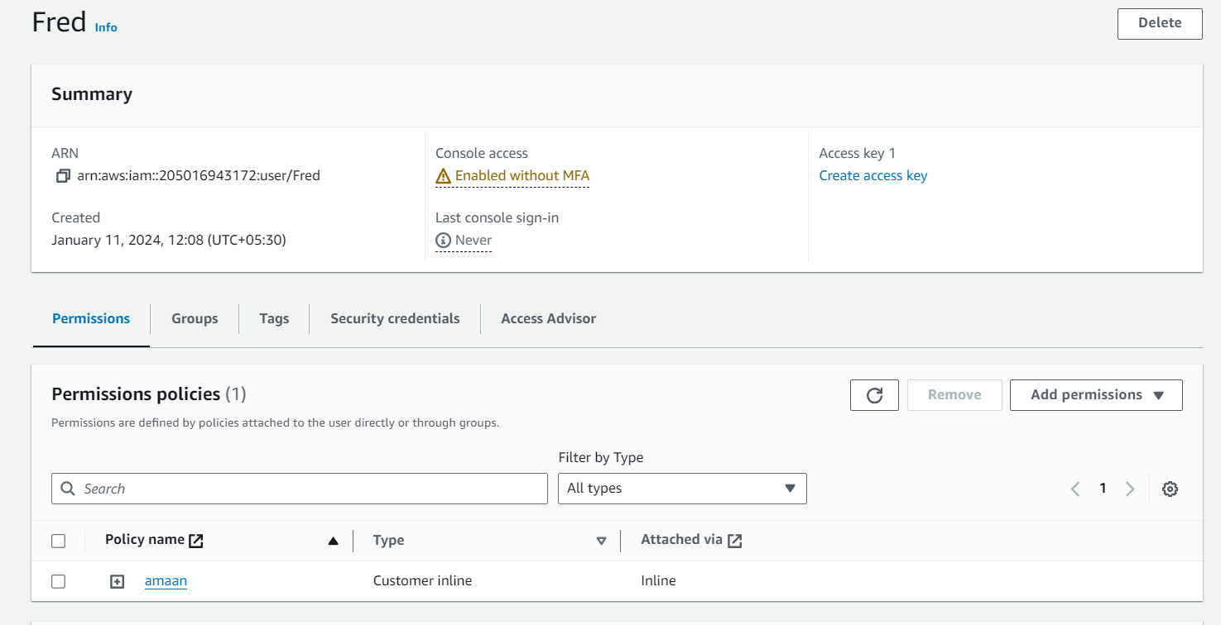

* **Log into the AWS account as an IAM user, add MFA, install AWS CLI,configure it in the terminal, and list IAM user actions using CLI command.**

